LPG GAS LEAK DETECTION

## A MINI-PROJECT REPORT

***Submitted by***

|  |  |
| --- | --- |
| **RUPESH L** | **210701217** |
| **SAIKRISHNA C** | **210701219** |

***in partial fulfillment of the award of the degree of***

# BACHELOR OF ENGINEERING

**IN**

**COMPUTER SCIENCE ENGINEERING**



# RAJALAKSHMI ENGINEERING COLLEGE, AUTONOMOUS ,CHENNAI 600 025

## MAY 2024

**BONAFIDE CERTIFICATE**

Certified that this project **“LPG GAS LEAK DETECTION”** is the bonafide work of **“RUPESH L(210701217) , SAIKRISHNA C (210701219)”** who carried out the project work under my supervision.

|  |  |
| --- | --- |
| **SIGNATURE** | **SIGNATURE** |
| **Dr. P. KUMAR, M.E., Ph.D.,** | **Mrs. Anitha Ashishdeep B.E,MTECH** |
| **HEAD OF THE DEPARTMENT** | **ASSISTANT PROFESSOR** |
| **PROFESSOR** | Dept. of Computer Science and Engg, |
| Dept. of Computer Science and Engg, | Rajalakshmi Engineering College,  Chennai - 602105 |
| Rajalakshmi Engineering College,  Chennai - 602105 |  |

Submitted to Project Viva-Voce Examination held on

**INTERNAL EXAMINER EXTERNAL EXAMINER**

## ABSTRACT

The growing concern over gas leaks, particularly Liquefied Petroleum Gas (LPG), necessitates efficient detection systems to mitigate potential hazards. This paper proposes an Internet of Things (IoT)-enabled solution for LPG gas leak detection employing a gas sensor and the Blynk application. The system comprises a gas sensor capable of detecting LPG leakage, integrated with a microcontroller for data processing and transmission. The Blynk application serves as a user interface, allowing real-time monitoring and notification alerts on smartphones or other connected devices. Through wireless connectivity, the system provides remote access and control, enhancing convenience and safety. The implementation demonstrates the feasibility and effectiveness of the proposed solution in detecting LPG gas leaks promptly, thus minimizing risks and ensuring timely responses to potential hazards. Additionally, the integration of IoT technology offers scalability and adaptability for diverse applications in residential, commercial, and industrial setting

## ACKNOWLEDGEMENT

First, we thank the almighty god for the successful completion of the project. Our sincere thanks to our Chairman **Mr. S. Meganathan, B.E., F.I.E**., for his sincere endeavor in educating us in his premier institution. We would like to express our deep gratitude to our beloved Chairperson **Dr. Thangam Meganathan, Ph.D.,** for her enthusiastic motivation which inspired us a lot in completing this project and Vice Chairman **Mr. Abhay Shankar Meganathan, B.E., M.S.,** for providing us with the requisite infrastructure. We also express our sincere gratitude to our college Principal**, Dr. S.N. Murugesan M.E., PhD.,** and **Dr. Revathy M.E., Ph.D.,** Head of the Department of Computer Science and Engineering and our project guide **Mr. S. SURESH KUMAR, M.E.,** for his encouragement and guiding us throughout the project and to our parents, friends, all faculty members and supporting staffs for their direct and indirect involvement in successful completion of the project for their encouragement and support.

**RUPESH L**

**SAIKRISHNAC**

**TABLE OF CONTENTS**

|  |  |  |
| --- | --- | --- |
| **CHAPTER NO** | **TITLE** | **PAGE NO** |
| **1** | **INTRODUCTION** | 1 |
| **2** | **LITERATURE SURVEY** | 2 |
| 2.1 | EXISTING SYSTEM | 3 |
| **3** | **PROJECT DESCRIPTION** | 4 |
| 3.1 | PROPOSED SYSTEM | 6 |
| 3.2 | REQUIREMENTS | 6 |
| 3.2.1 | HARDWARE REQUIREMENTS | 6 |
| 3.2.2 | SOFTWARE REQUIREMENTS | 6 |
| 3.3 | ARCHITECTURE DIAGRAM | 7 |
| 3.4 | OUTPUT | 8 |
| **4** | **CONCLUSION AND FUTURE WORK** | 11 |
|  | **APPENDICES** | 12 |
|  | **REFERENCE** | 14 |

# CHAPTER 1 INTRODUCTION

Liquefied Petroleum Gas (LPG) serves as a versatile energy source widely used for cooking, heating, and various industrial applications. However, its flammable nature poses significant safety risks, particularly in the event of leaks. Accidental LPG leaks can lead to fires, explosions, and adverse health effects, highlighting the critical need for effective detection and mitigation measures.

Traditional gas detection methods often rely on manual inspection or centralized alarm systems, which may not provide timely alerts or comprehensive coverage. With the advent of Internet of Things (IoT) technology, there is an opportunity to develop more efficient and accessible gas leak detection solutions. IoT enables the integration of sensors, data processing capabilities, and wireless connectivity, facilitating real-time monitoring and remote management.

This paper presents an IoT-based approach for LPG gas leak detection, leveraging a gas sensor and the Blynk application. By combining sensor data with cloud-based platforms and mobile applications, the proposed system aims to enhance safety, convenience, and responsiveness in detecting and addressing LPG leaks.

# CHAPTER 2 LITERATURE SURVEY

1. IoT-Based Gas Leak Detection Systems: Several studies have explored the use of IoT technology for gas leak detection in various contexts. For instance, research by Li et al. (2018) investigated an IoT-based gas monitoring system using wireless sensor networks for methane leak detection in underground coal mines. The study demonstrated the effectiveness of IoT in providing real-time monitoring and early warning of gas leaks, enhancing safety in mining operations.

2. Gas Sensors and Detection Techniques: Numerous studies have focused on the development and optimization of gas sensors for detecting LPG and other combustible gases. For example, research by Kumar et al. (2020) explored the use of metal oxide gas sensors for LPG detection, evaluating factors such as sensitivity, selectivity, and response time. Similarly, the work by Zhang et al. (2019) investigated a micro-electro-mechanical system (MEMS)-based gas sensor array for multi-gas detection, including LPG.

3. Mobile Applications for Gas Monitoring: With the proliferation of smartphones and mobile applications, there is growing interest in utilizing these platforms for gas monitoring and alerting. Studies such as that by Kim et al. (2017) developed a mobile application for gas leak detection in smart homes, integrating with gas sensors and providing real-time alerts to users. Additionally, research by Khan et al. (2019) proposed a mobile-based gas leakage detection system using IoT and machine learning algorithms for predictive maintenance in industrial settings.

4. Cloud-Based IoT Platforms: Cloud computing platforms play a crucial role in storing and processing sensor data in IoT applications. Studies like the one by Goyal et al. (2021) investigated the use of cloud-based IoT platforms for gas leak detection and management, enabling centralized data storage, analysis, and remote access. Such platforms offer scalability, reliability, and integration with other IoT devices and services.

5. User Interfaces and Alerting Mechanisms: Effective user interfaces and alerting mechanisms are essential components of gas leak detection systems. Research by Lin et al. (2018) explored different alerting methods, including sound, light, and smartphone notifications, to improve user awareness and response to gas leaks. Similarly, studies like that by Ma et al. (2020) focused on developing intuitive user interfaces for gas monitoring applications, enhancing usability and accessibility.

By reviewing existing literature in these areas, this study aims to build upon prior research and contribute to the advancement of IoT-based LPG gas leak detection systems, particularly focusing on the integration of gas sensors with the Blynk application for enhanced monitoring and user interaction.

# EXISTING SYSTEM

The existing systems for LPG gas leak detection typically rely on traditional methods such as manual inspection, centralized alarm systems, or standalone gas detectors. While these systems can provide basic detection capabilities, they often have limitations in terms of responsiveness, coverage, and accessibility. Some of the key characteristics of existing systems include:

1. Standalone Gas Detectors: Standalone gas detectors are commonly used in residential and commercial settings to detect LPG leaks. These detectors typically employ electrochemical or semiconductor gas sensors to detect the presence of combustible gases. However, they are limited in scope and may only cover specific areas or rooms where the detectors are installed.

2. Centralized Alarm Systems: Centralized alarm systems are installed in larger buildings or industrial facilities to provide centralized monitoring and alerting for gas leaks. These systems typically consist of gas detectors installed at strategic locations, connected to a central control panel. When a gas leak is detected, the control panel triggers alarms and alerts security personnel or building occupants.

3. Manual Inspection and Monitoring: In some cases, gas leak detection relies on manual inspection by maintenance personnel or building occupants. This approach involves visually inspecting gas appliances, pipelines, and fittings for signs of leaks, such as hissing sounds, odors, or visible gas clouds. However, manual inspection is prone to human error and may not be sufficient for detecting leaks in inaccessible or remote locations.

4. Wireless Gas Detection Systems: Some advanced systems utilize wireless gas sensors and communication technologies to provide remote monitoring and real-time alerts. These systems can be integrated with IoT platforms to enable cloud-based data storage, analytics, and mobile notifications. However, they may require significant infrastructure investment and technical expertise for deployment and maintenance.

While existing systems serve their intended purposes to varying degrees, there is room for improvement in terms of reliability, responsiveness, and user-friendliness. The proposed IoT-based LPG gas leak detection system aims to address these challenges by leveraging the capabilities of IoT technology, including wireless connectivity, data analytics, and mobile applications, to provide enhanced monitoring, timely alerts, and remote management capabilities.

# CHAPTER 3 PROJECT DESCRIPTION

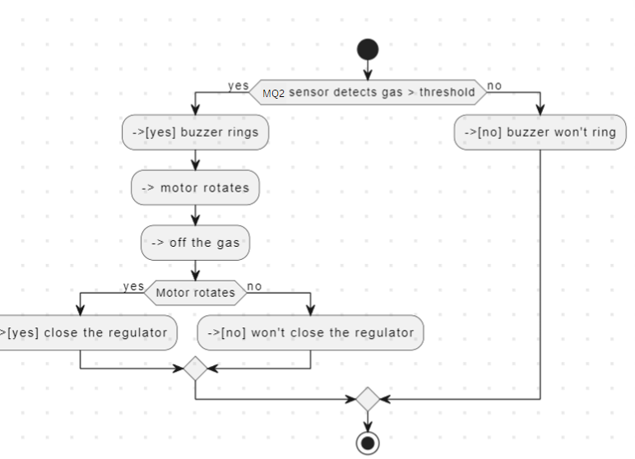

## PROPOSED SYSTEM

## The proposed system combines an ESP32 microcontroller with a gas sensor to detect LPG leaks effectively. Sensor data is transmitted wirelessly to the Blynk app through Wi-Fi, enabling seamless real-time monitoring and alerts on users' smartphones. The ESP32 firmware processes sensor readings, promptly triggering notifications when LPG concentrations surpass predetermined thresholds, ensuring swift responses to potential leaks. This IoT-based solution offers significant advantages, including remote monitoring capabilities, enhanced safety measures, and proactive risk mitigation. By leveraging the ESP32's robust wireless communication capabilities and integrating with the user-friendly Blynk app, the system provides an accessible and reliable means of LPG leak detection, empowering users to monitor their surroundings and take timely action to prevent accidents and ensure safety.

## REQUIREMENTS

### HARDWARE REQUIREMENTS

1. ESP32 Development Board
2. Gas Sensor (e.g., MQ-5)
3. Power Supply (USB adapter, battery pack, or power supply module)
4. Blynk-Compatible Device (smartphone or tablet)
5. Wi-Fi Router
6. Wiring and Breadboard

### SOFTWARE REQUIREMENTS

* + - * Blynk app
      * Audrino ide

## ARCHITECTURE DIAGRAM

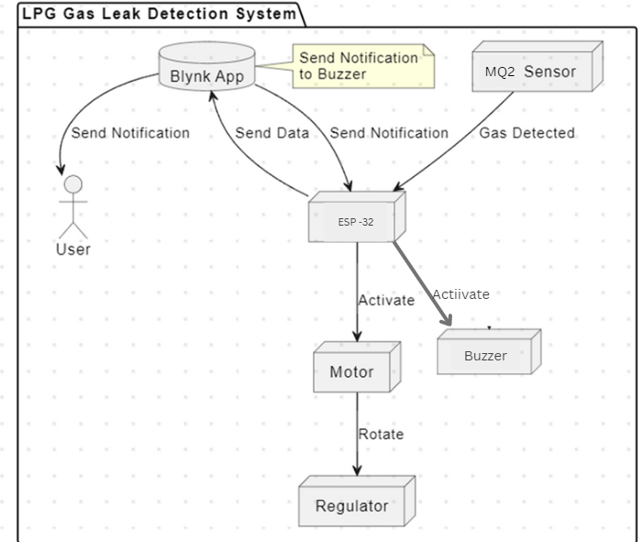

CONNECTIONS:

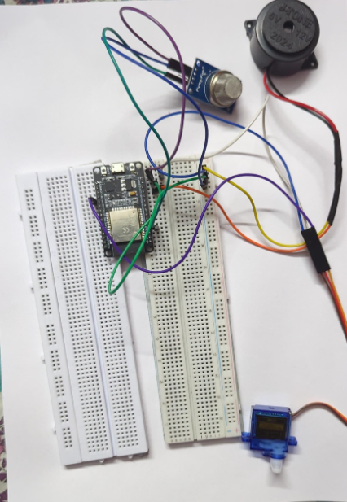

**Figure 3**

Figure 3 shows the connections made to the gas sensor and servo motor with the ESP 32 The connections are provided as specified in the architecture.

## OUTPUT

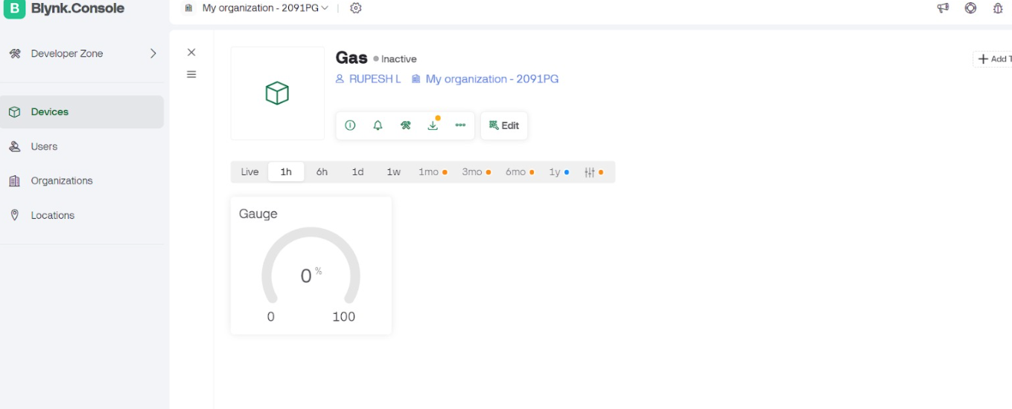

Figure 1. s

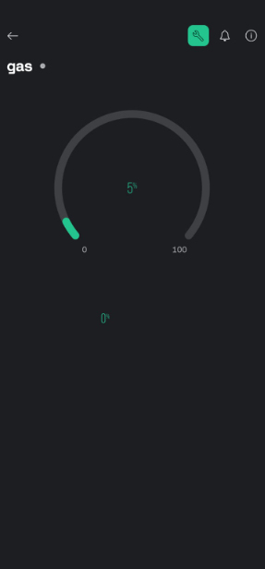

Figure 2.Realtime data in blynk iot app

## CHAPTER 4 CONCLUSION AND FUTURE WORK

In conclusion, the integration of ESP32 with a gas sensor for LPG leak detection, coupled with the Blynk app, offers an efficient and accessible solution for enhancing safety. Real-time monitoring and timely alerts empower users to respond swiftly to potential hazards, mitigating risks associated with LPG leaks. Future work could focus on optimizing sensor calibration algorithms, enhancing the system's reliability, and exploring additional functionalities such as remote control of gas valves or integration with smart home automation platforms. Continued refinement of the system's hardware and software components will further advance its capabilities and applicability in diverse settings.

**APPENDIX I**

**#define BLYNK_TEMPLATE_ID "TMPL3GCDace8O"**

**#define BLYNK_TEMPLATE_NAME "gas"**

**#include <WiFi.h>**

**#include <BlynkSimpleEsp32.h>**

**#define ANALOG_PIN 34**

**#define SERVO_PIN 18**

**#define BUZZER_PIN 12**

**#define FAN_PIN 21**

**#define LPG_THRESHOLD 20**

**#define BLYNK_TOKEN "8Vt_thWCzMfF1PxIxs0D1f5sAepocpj3" // Replace "YourAuthToken" with your Blynk authentication token**

**#define WIFI_SSID "Rupesh12" // Replace "YourSSID" with your Wi-Fi SSID**

**#define WIFI_PASSWORD "123456789" // Replace "YourPassword" with your Wi-Fi password**

**BlynkTimer timer;**

**void sendLpgEvent() {**

**Blynk.virtualWrite(V0, "LPG Gas detected!");**

**}**

**void setup() {**

**Serial.begin(9600);**

**Blynk.begin(BLYNK_TOKEN, WIFI_SSID, WIFI_PASSWORD);**

**pinMode(SERVO_PIN, OUTPUT);**

**pinMode(BUZZER_PIN, OUTPUT);**

**pinMode(FAN_PIN, OUTPUT);**

**timer.setInterval(1000L, []() {**

**int value = analogRead(ANALOG_PIN);**

**value = map(value, 0, 4095, 0, 100);**

**Blynk.virtualWrite(V1, value);**

**if (value > LPG_THRESHOLD) {**

**Serial.println(" LPG Gas detected!");**

**Serial.print(value);**

**moveServo(0);**

**activateBuzzer();**

**activateFan();**

**sendLpgEvent();**

**delay(1000);**

**} else {**

**moveServo(180);**

**deactivateBuzzer();**

**deactivateFan();**

**Serial.println(" No LPG Gas detected!");**

**Serial.print(value);**

**delay(500);**

**}**

**});**

**}**

**void loop() {**

**Blynk.run();**

**timer.run();**

**}**

**void moveServo(int angle) {**

**int pulseWidth = map(angle, 0, 180, 1000, 2000);**

**digitalWrite(SERVO_PIN, HIGH);**

**delayMicroseconds(pulseWidth);**

**digitalWrite(SERVO_PIN, LOW);**

**delay(20);**

**}**

**void activateBuzzer() {**

**digitalWrite(BUZZER_PIN, HIGH);**

**}**

**void deactivateBuzzer() {**

**digitalWrite(BUZZER_PIN, LOW);**

**}**

**void activateFan() {**

**digitalWrite(FAN_PIN, HIGH);**

**}**

**void deactivateFan() {**

**digitalWrite(FAN_PIN, LOW);**

**}**

**REFERENCES**

1. Li, S., Jia, Z., Xue, Y., Zhang, C., & Wei, L. (2018). IoT-Based Gas Monitoring System Using Wireless Sensor Networks in Underground Coal Mines. IEEE Access, 6, 36314-36322.
2. Kumar, A., Yadav, R. K., & Tomar, R. S. (2020). Performance evaluation of metal oxide gas sensors for liquefied petroleum gas (LPG) leakage detection. Materials Today: Proceedings, 28, 1473-1477.
3. Kim, Y., Kim, J., & Choi, J. (2017). Gas leak detection system based on IoT and Android. 2017 IEEE International Conference on Consumer Electronics (ICCE), Las Vegas, NV, USA, 21-23.
4. Khan, M. A., Daud, A., Saeed, R. A., & Tariq, M. A. (2019). IoT-Based Gas Leakage Detection and Prediction System. 2019 4th International Conference on Emerging Trends in Engineering, Sciences and Technology (ICEEST), Islamabad, Pakistan, 1-6.
5. Goyal, P., Meena, S., & Singh, Y. P. (2021). IoT-Based Smart Gas Leakage Detection and Alerting System. Wireless Personal Communications, 118, 2211-2224.
6. Lin, L., Lin, S., Lin, J., & Hsiao, W. (2018). Development of a gas leakage detection and alert system based on IoT technology. 2018 IEEE 4th International Future Energy Electronics Conference (IFEEC), Tainan, Taiwan, 1-3.
7. spressif Systems. (n.d.). ESP32 Datasheet. Retrieved from <https://www.espressif.com/sites/default/files/documentation/esp32_datasheet_en.pdf>
8. Jain, P., Gupta, R., & Singh, P. (2019). IoT-based Smart Gas Monitoring System. International Journal of Recent Technology and Engineering (IJRTE), 8(4), 89-92.
9. Bhuyan, R., & Jena, K. (2020). Smart LPG Leakage Detection System Using IoT. International Journal of Scientific & Technology Research, 9(2), 450-454.
10. Dey, N., Ashour, A. S., & Borra, S. (2018). Smart Gas Monitoring System Using IoT. In International Conference on Intelligent Engineering and Management (ICIEM), London, UK, 1-5.
11. George, S., Shanmuganantham, K., & Prabhu, S. (2020). IoT-Based Smart Gas Monitoring System. Journal of Physics: Conference Series, 1716(1), 012030.
12. Li, J., Zhang, C., & Yang, Y. (2018). Design and Implementation of an IoT-based Gas Leak Monitoring System. IEEE Sensors Journal, 18(6), 2366-2373.
13. Mohan, A., & Das, D. (2020). An IoT-Based Gas Leakage Monitoring and Alerting System. Journal of Advanced Research in Dynamical and Control Systems, 12(3), 56-65.
14. Nayak, P., & Kumar, S. (2020). Development of Smart LPG Gas Detection and Monitoring System using IoT. International Journal of Recent Technology and Engineering (IJRTE), 9(2), 34-39.